Sprinklers Required in Electrical Rooms? [PDF]
8/17/2022

Awhile back I wrote a piece on sprinklers in electrical rooms. At the time I was asked relatively frequently about when sprinklers are required or allowed to be omitted in electrical rooms.
I guess intuitively, we recognize that electricity and water don’t mix well. We don’t want to address one problem (fire) by creating a new hazard (electrocution) with water in areas that it doesn’t have to be.
In principle, I personally have just about always provided sprinklers in electrical rooms unless they were specifically requested not to be provided by the owner or AHJ; and in those cases, I followed the code path in the IBC or NFPA 13 accordingly.
It seems as though the premise behind not including sprinklers is when the type of electrical equipment present a relatively low hazard or fuel source, and there is no storage. In that situation, a combination of 2-hour fire-resistance-rated enclosure with approved fire detection (assuming a smoke and/or heat detector here) will mean that a fire within the room will be recognized, and the rest of the building will not be compromised as a result.
Providing pipe within an electrical room isn’t always an easy feat. NFPA 70 tells us that electrical equipment requires dedicated zones, and pipe shouldn’t be run above panels without drip pans or other methods of avoiding drip hazards above electrical equipment.
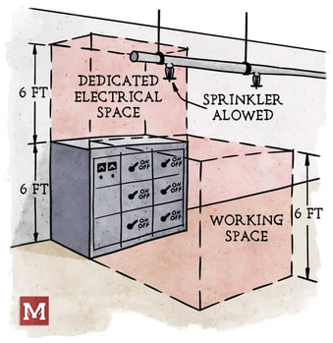
Now are sprinklers in electrical rooms problematic? Generally not (in my experience).
Can pipe routing be made to avoid electrical equipment? Usually yes. I try to only run one branch line into the room, most often above the door (since no electrical equipment is on the door), and stick pipe only above walking pathways within the room.
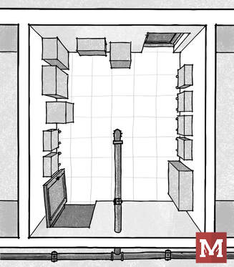
Does the code or standards express any concern or guidance on this? Yes, both the IBC and NFPA 13 address the situation.
​
One line that is included in the IBC specifically says that sprinklers “shall not be omitted from any room merely because it...contains electrical equipment”. To me, that’s a fairly explicit way of suggesting that the presence of electrical equipment alone isn’t a justification for omitting sprinklers. Now there are code allowances and necessary provisions to do so, but the suggestion is not to simply avoid sprinklers just because there is electrical gear

